WEEK 3
Unsupervised Learning and Clustering Analysis
Iris Flower Dataset
Python Data Science Internship
Scikit-learn • K-Means • Hierarchical Clustering • PCA

Executive Summary
This report applies unsupervised learning to the publicly available Iris dataset. Four numerical flower measurements are standardized and clustered without supplying species labels to the algorithm. K-Means is the primary method, while hierarchical Ward clustering provides a secondary comparison.
Candidate K values from 2 to 6 were evaluated. Silhouette score is highest at K=2 (0.582), while the elbow curve and the practical interpretability of the Iris structure support K=3. The final analysis therefore uses K=3 and explicitly records this model-selection trade-off.
The K=3 solution produces three interpretable groups. Hierarchical clustering with three groups gives a silhouette score of 0.447. Known species labels are used only after clustering for post-hoc interpretation.

1. Objectives
- Select a public dataset appropriate for clustering.
- Standardize continuous features for distance-based learning.
- Evaluate candidate cluster counts.
- Apply K-Means and interpret cluster profiles.
- Visualize clusters using PCA and feature plots.
- Compare with hierarchical clustering.
- Discuss implications and limitations.

2. Dataset Selection
The Iris dataset contains 150 observations and four continuous measurements: sepal length, sepal width, petal length, and petal width. Three species labels are available, but they are withheld from clustering and used only for post-hoc interpretation.
Item | Value
Observations | 150
Features | 4 continuous numerical features
Known labels | 3 species; not used during clustering
Primary method | K-Means

3. Preprocessing
StandardScaler puts the four measurements on comparable scales. This is important because K-Means uses distance calculations.
scaler = StandardScaler()
X_scaled = scaler.fit_transform(X)

4. Selecting the Number of Clusters
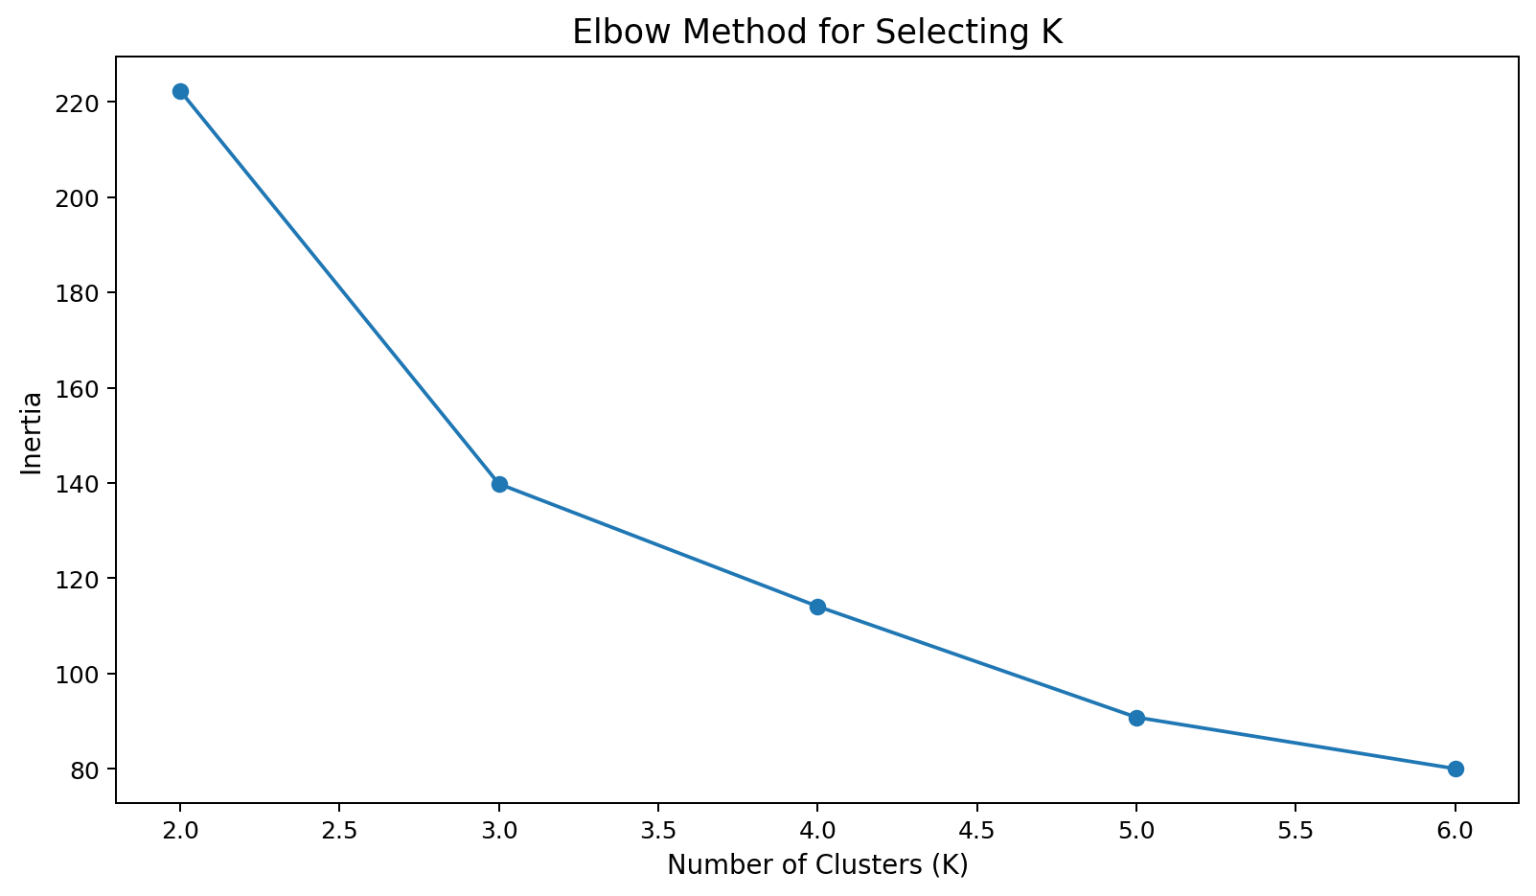
Figure 1. Elbow method.
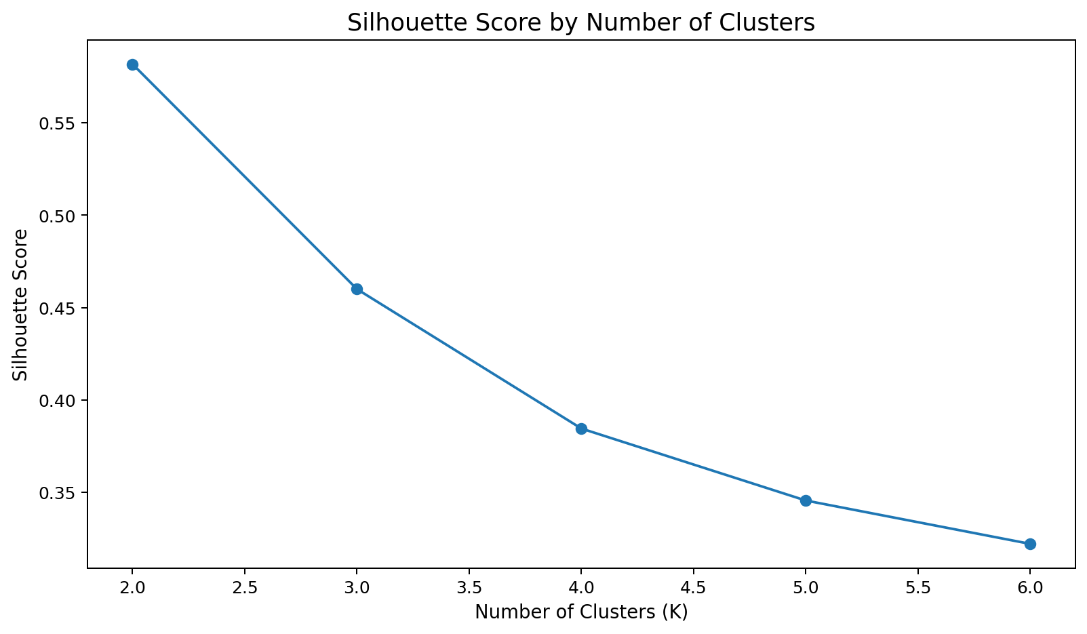
Figure 2. Silhouette scores.
K | Inertia | Silhouette
2 | 222.36 | 0.582
3 | 139.82 | 0.460
4 | 114.09 | 0.384
5 | 90.81 | 0.346
6 | 80.02 | 0.322
The silhouette metric alone favors K=2 (0.582). However, K=3 provides a more informative three-group segmentation and is supported by the elbow/interpretability trade-off. Selecting K=3 is therefore a documented analytical choice rather than a claim that K=3 uniquely maximizes every metric.
for k in range(2, 7):
model = KMeans(n_clusters=k, random_state=42, n_init=20)
labels = model.fit_predict(X_scaled)
print(k, model.inertia_, silhouette_score(X_scaled, labels))

5. K-Means Implementation
kmeans = KMeans(n_clusters=3, random_state=42, n_init=20)
labels = kmeans.fit_predict(X_scaled)
random_state supports reproducibility and n_init=20 evaluates multiple centroid initializations. Cluster IDs are arbitrary labels and do not represent an ordinal ranking.

6. PCA Visualization
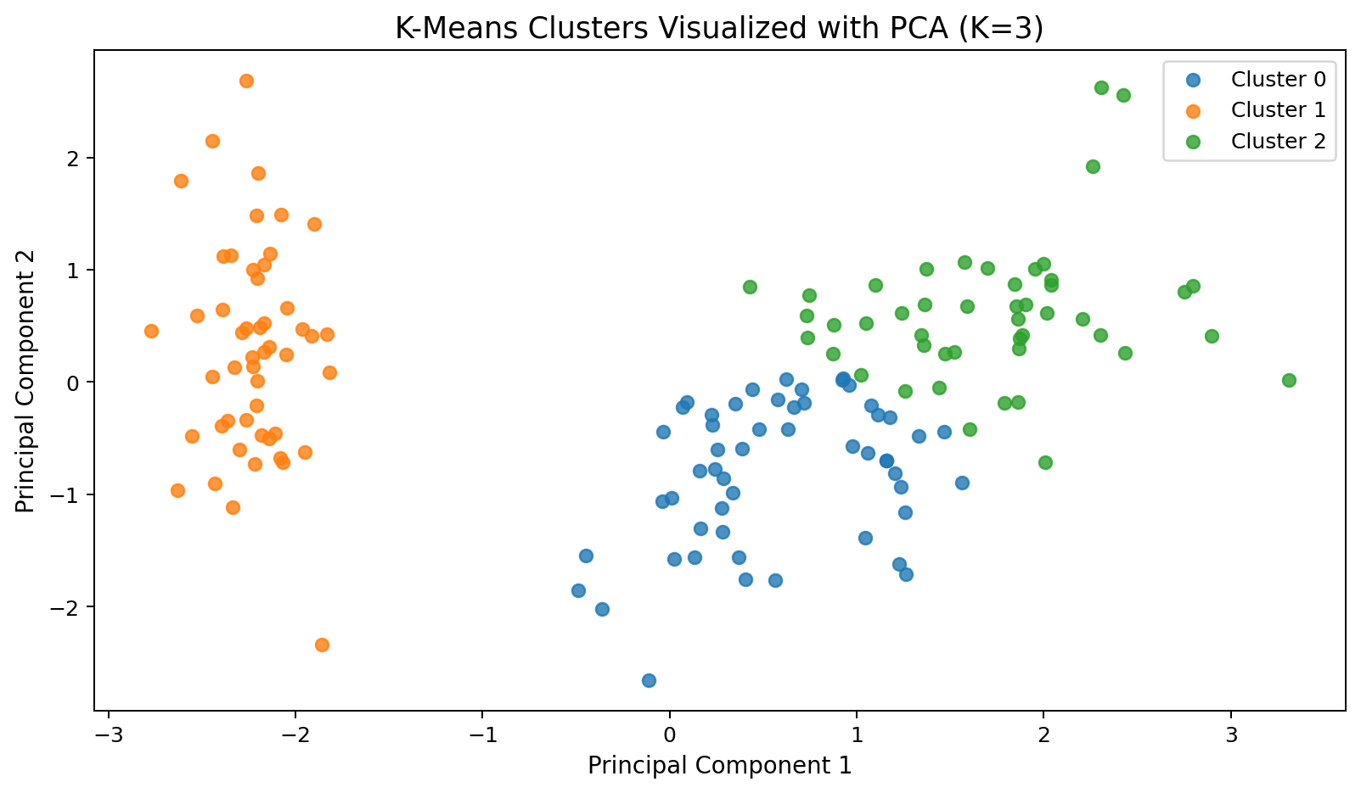
Figure 3. K-Means clusters projected onto two principal components.
PCA is used only for visualization. The first two components explain 95.8% of the standardized variance. The projection shows a compact separated group and greater overlap between the other groups.

7. Feature-Level Visualization
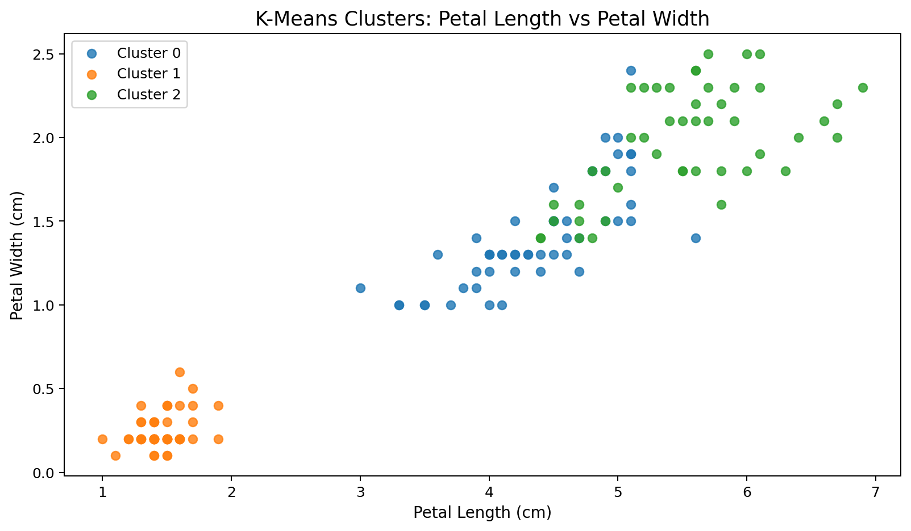
Figure 4. Cluster separation using petal length and petal width.
Petal length and petal width provide particularly clear separation among the discovered groups, indicating that petal morphology contributes strongly to the clustering structure.

8. Cluster Profiles
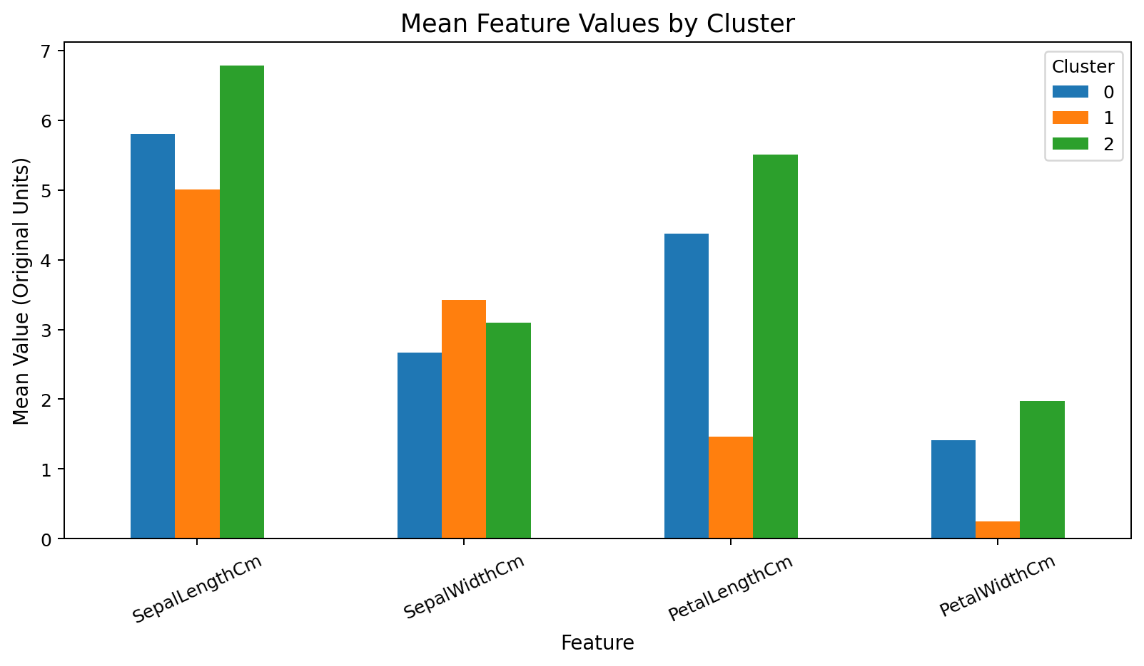
Figure 5. Mean feature values by cluster.
Cluster | Size | Sepal L | Sepal W | Petal L | Petal W
0 | 53 | 5.80 | 2.67 | 4.37 | 1.41
1 | 50 | 5.01 | 3.43 | 1.46 | 0.25
2 | 47 | 6.78 | 3.10 | 5.51 | 1.97
Cluster 0 contains 53 observations. Its mean measurements are 5.80 cm sepal length, 2.67 cm sepal width, 4.37 cm petal length, and 1.41 cm petal width. Its dominant known species after post-hoc comparison is versicolor.
Cluster 1 contains 50 observations. Its mean measurements are 5.01 cm sepal length, 3.43 cm sepal width, 1.46 cm petal length, and 0.25 cm petal width. Its dominant known species after post-hoc comparison is setosa.
Cluster 2 contains 47 observations. Its mean measurements are 6.78 cm sepal length, 3.10 cm sepal width, 5.51 cm petal length, and 1.97 cm petal width. Its dominant known species after post-hoc comparison is virginica.

9. Post-Hoc Species Comparison
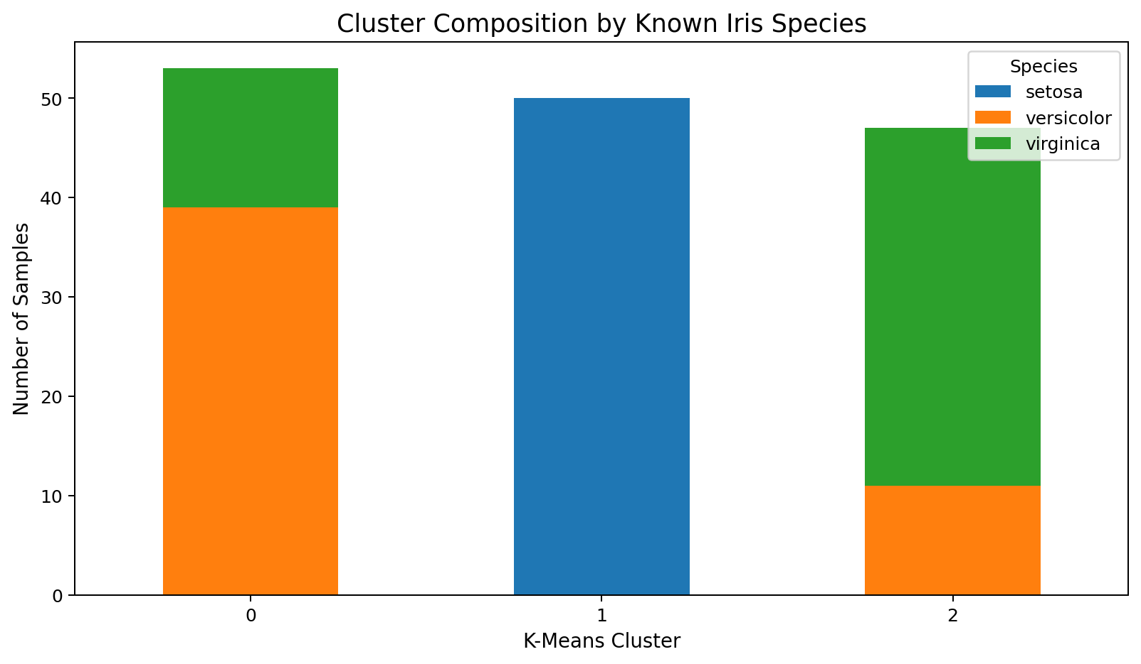
Figure 6. Cluster composition by known species; labels were not used during model fitting.
After clustering, known species were compared with the discovered groups. Two groups show strong concentration of a single species, while the intermediate group has more overlap. The mean dominant-species proportion is approximately 83.4%. This is not supervised classification accuracy.

10. Hierarchical Clustering
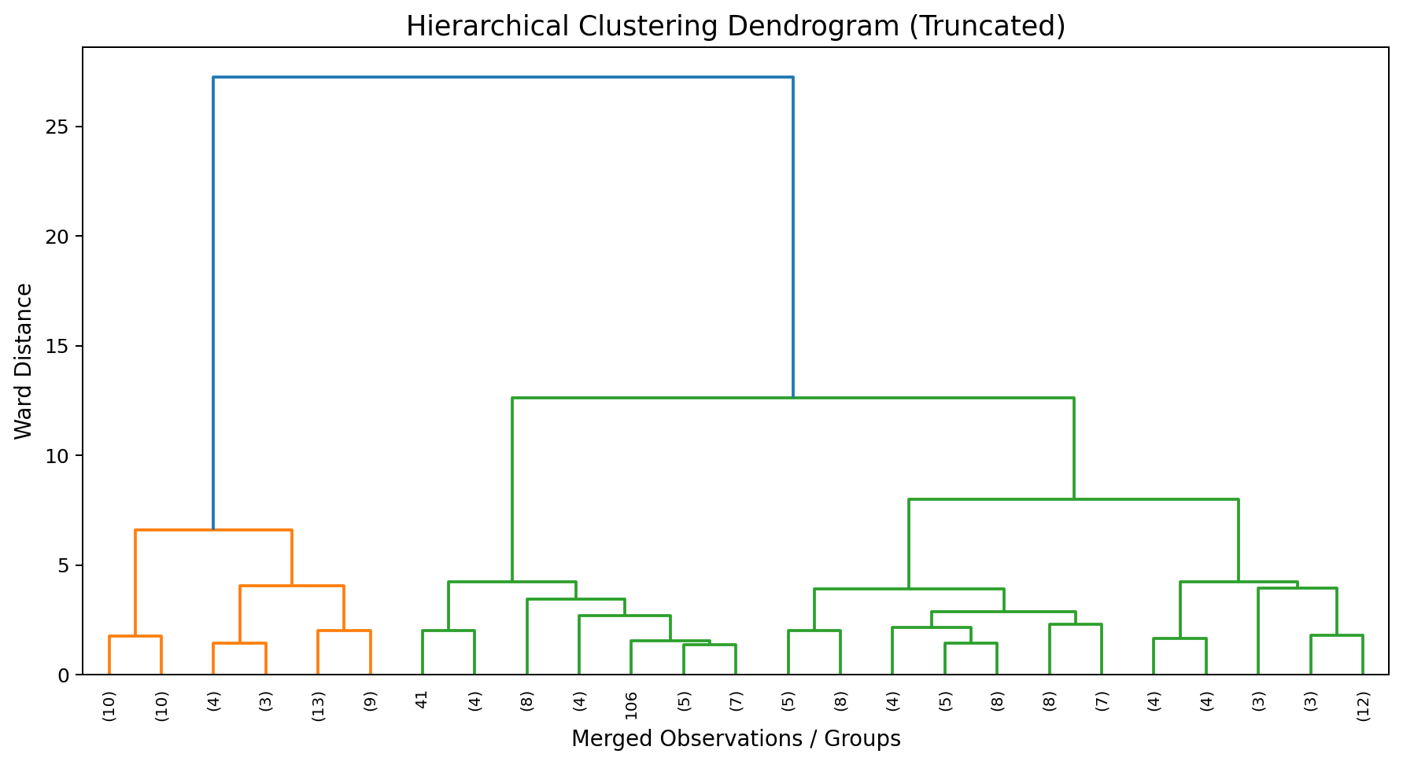
Figure 7. Truncated Ward-linkage dendrogram.
Agglomerative clustering using Ward linkage and three clusters achieved a silhouette score of 0.447. The dendrogram provides a complementary view of the hierarchical structure in the standardized feature space.
agg = AgglomerativeClustering(n_clusters=3, linkage="ward")
agg_labels = agg.fit_predict(X_scaled)
print(silhouette_score(X_scaled, agg_labels))

11. Potential Applications
- Customer segmentation without pre-existing labels.
- Product or record grouping based on measurable attributes.
- Cluster profiling for targeted analysis.
- Hypothesis generation for later supervised modeling.
- Identifying groups that deserve separate operational or research analysis.

12. Challenges and Limitations
- Silhouette and elbow evidence can disagree; this analysis transparently records that silhouette favors K=2 while K=3 was selected for interpretability.
- K-Means is sensitive to scaling, initialization, and the chosen K.
- PCA is a visualization aid and can hide higher-dimensional structure.
- Cluster IDs are arbitrary and can change order.
- Iris is small and unusually clean compared with many real-world datasets.
- Known labels are used only after clustering for interpretation.
- Clustering is descriptive and does not establish causation.

13. Reproducibility
The project package includes clustering_iris.py, iris_clustered.csv, cluster_selection_metrics.csv, seven figures, and this report. The Python script reproduces scaling, candidate-K evaluation, K-Means fitting, PCA visualization, and hierarchical clustering comparison.

14. Conclusion
This project demonstrates a complete unsupervised-learning workflow from dataset selection and preprocessing through model selection, clustering, visualization, profiling, and method comparison. The final K=3 segmentation is useful and interpretable, while the report transparently records that silhouette score alone favors K=2. This demonstrates why clustering decisions should combine quantitative evidence with the purpose of the analysis.

Appendix — Core Python Code
# Week 3: Unsupervised Learning and Clustering
from sklearn.datasets import load_iris
from sklearn.preprocessing import StandardScaler
from sklearn.cluster import KMeans, AgglomerativeClustering
from sklearn.metrics import silhouette_score
from sklearn.decomposition import PCA
import pandas as pd
import matplotlib.pyplot as plt
iris = load_iris(as_frame=True)
X = iris.data
X.columns = ["SepalLengthCm","SepalWidthCm","PetalLengthCm","PetalWidthCm"]
scaler = StandardScaler()
X_scaled = scaler.fit_transform(X)
# Compare candidate values of K
scores = []
for k in range(2, 7):
model = KMeans(n_clusters=k, random_state=42, n_init=20)
labels = model.fit_predict(X_scaled)
scores.append((k, model.inertia_, silhouette_score(X_scaled, labels)))
metrics = pd.DataFrame(scores, columns=["K","Inertia","Silhouette"])
print(metrics)
# Final K=3 solution: selected from elbow/interpretability trade-off.
# Silhouette alone favors K=2; this is reported explicitly in the report.
kmeans = KMeans(n_clusters=3, random_state=42, n_init=20)
labels = kmeans.fit_predict(X_scaled)
result = X.copy()
result["Cluster"] = labels
print(result.groupby("Cluster").mean())
# PCA only for 2-D visualization
pca = PCA(n_components=2, random_state=42)
X_pca = pca.fit_transform(X_scaled)
# Secondary hierarchical comparison
agg = AgglomerativeClustering(n_clusters=3, linkage="ward")
agg_labels = agg.fit_predict(X_scaled)
print("Hierarchical silhouette:", silhouette_score(X_scaled, agg_labels))
for c in sorted(result["Cluster"].unique()):
idx = result["Cluster"] == c
plt.scatter(X_pca[idx,0], X_pca[idx,1], label=f"Cluster {c}")
plt.title("K-Means Clusters Visualized with PCA")
plt.xlabel("Principal Component 1")
plt.ylabel("Principal Component 2")
plt.legend()
plt.show()

